**Sporty Shoes.**

(A**n E-Commerce Website.**)

***(Application Screenshot’s)***



* Version History:

|  |  |  |
| --- | --- | --- |
| **1.** | **Author Name** | **Ankita Asati** |
| **2.** | **Purpose** | Screenshots of Application. |
| **3.** | **Date** | 27 Feb 2023 |
| **4.** | **Version** | 1.0 |
| **5.** | **Contact** | [*asati.ankita12@gmail.com*](mailto:asati.ankita12@gmail.com) |

# Contents.

**1. Project Outputs.** 3

1. Project Outputs.

|  |  |  |
| --- | --- | --- |
|  | 1) Home Page. |  |
|  |  |  |

|  |  |  |
| --- | --- | --- |
|  | 2) Login Page and Registration Page |  |
|  |  |  |

* 1. Home Page After Login.

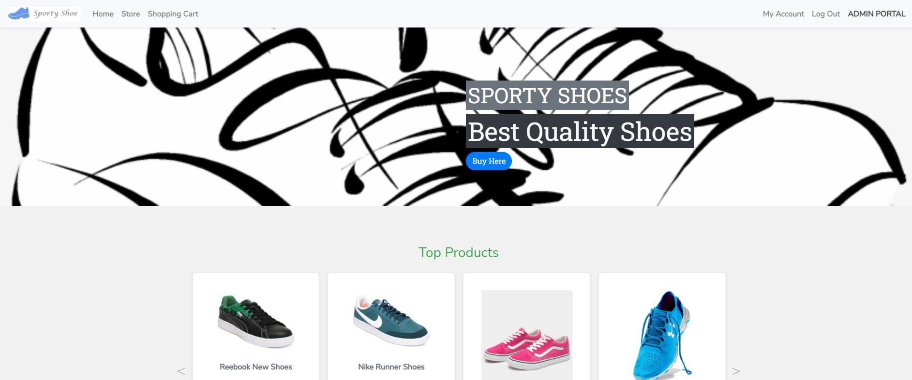

* 1. Admin Login

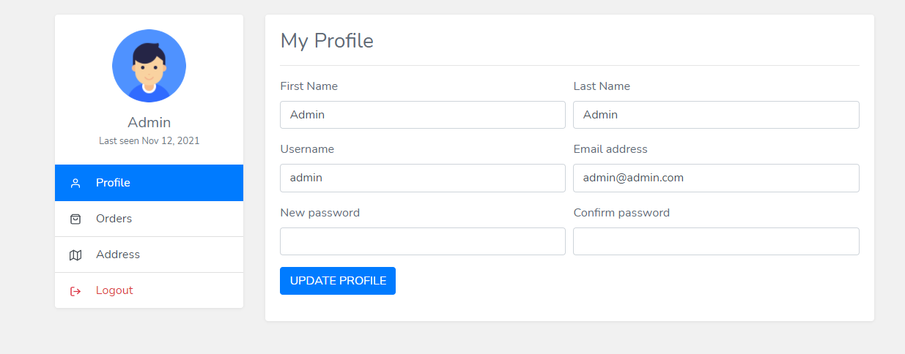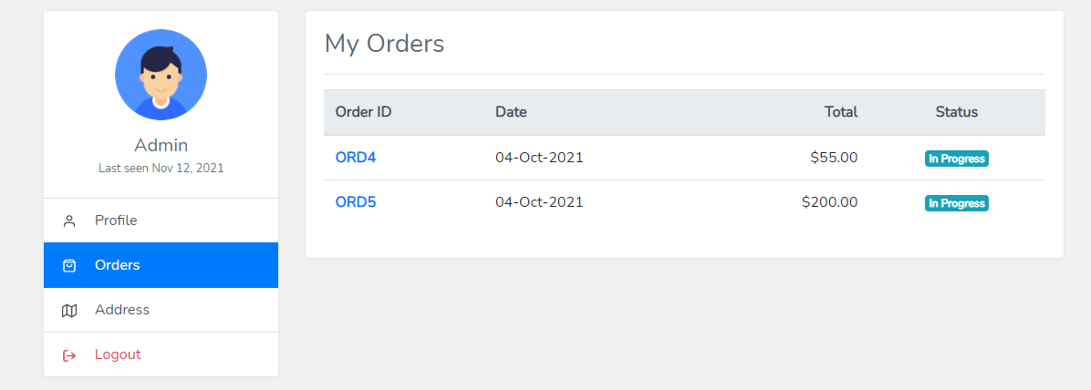

**a. Active Orders/My Orders.**

* 1. Shopping Cart.

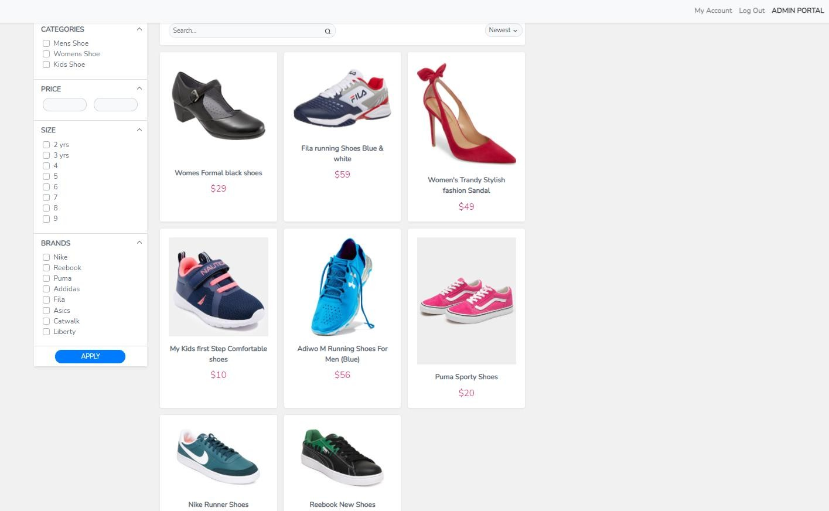

* 1. Admin Portal.

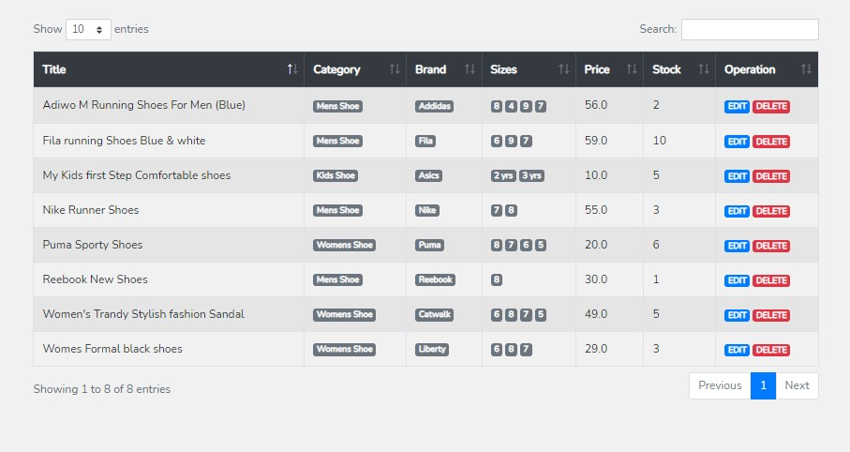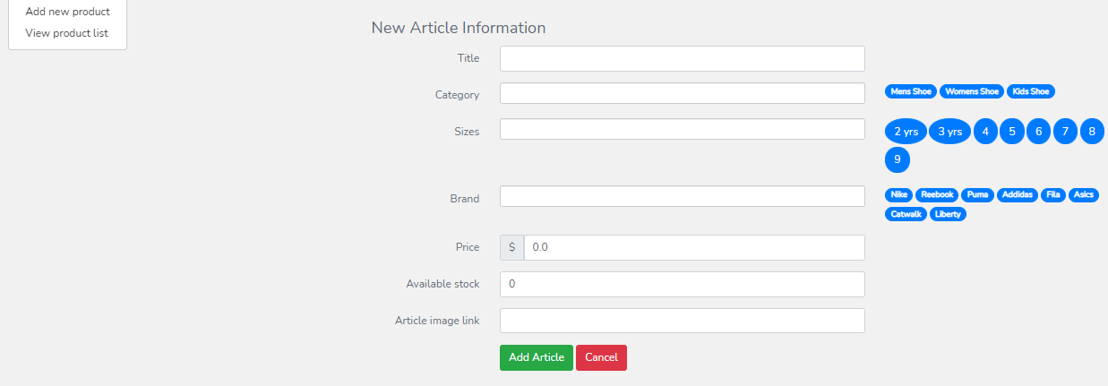

a. Product Menu - (Product List)

- (Add New Product)

1. User List.

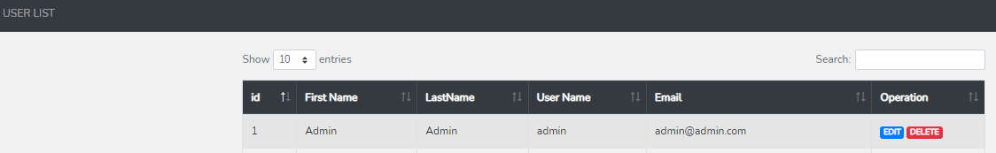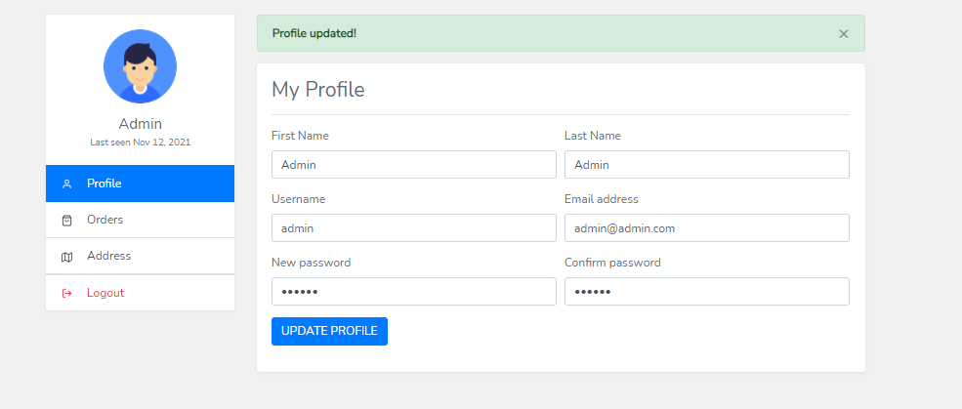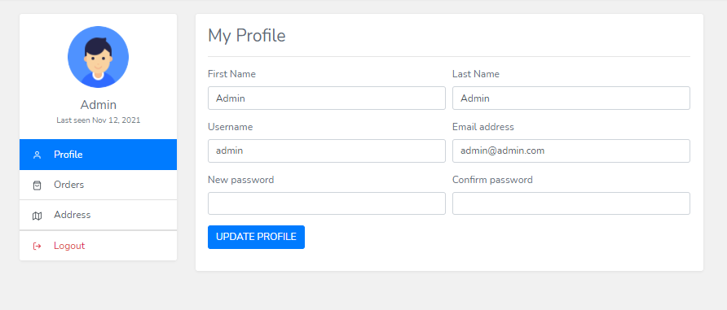

1. Password.

*Password Update Successfully……………*

1. Shopping Cart.

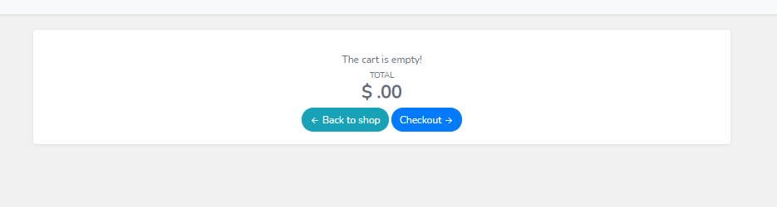

# ……….Thank You………